**S. Y. B. Tech. (EE)**

**Trimester: IV Subject: RES**

**Name: Shreerang Mhatre Class: S.Y.B.Tech (Electrical)**

**Roll No: 29 Batch: A2**

**Experiment No: 05**

**Name of the Experiment**: Case Study

**Marks**

**Teacher’s Signature with date**

**Performed on: 13/04/2023**

**Submitted on: 19/04/2023**

**Introduction:**

With nearly 3 quarters of our planet covered with water, and more and more people living and feeding from the increasingly scarcer lands, isn’t it a brilliant idea to start using our water surfaces for clean power generation? Floating solar panels is the answer, also known as floating photovoltaic (FPV) systems, are solar panels that are installed on floating structures such as rafts or pontoons, which are placed on bodies of water like lakes, reservoirs, and oceans. The panels can be either mounted on floating platforms that are anchored to the bottom of the water body or they can be free-floating.

Solaris Float Proteus is a modular floating solar solution developed by Ciel & Terre, a French company that specializes in floating solar photovoltaic (PV) systems. The technology involves installing solar panels on floating structures that are placed on water bodies such as lakes, reservoirs, ponds and in coastal areas, potentially solving many issues plaguing solar technology. Its solar panels can meticulously track the sun as it passes through the sky, maximizing energy yield.

**Location:**

The floating solar panel island, Proteus, is located in Oostvoornse Meer, a southwest Netherlands lake. The floating structure is covered in 180 solar panels whose total installed capacity is 73 kilowatts of peak power (kWp).

**Agencies and supporters:**

SOLARIS FLOAT, a jp.group company, a Portuguese business group in partnership with Ciel & Terre, a French company that specializes in floating solar photovoltaic (PV) systems, TNO (which includes Sabic, Equinor and the Municipality of Westvoorne) and in support with the French and Netherland Government.

**Objectives:**

The main objective of Solaris Float Proteus is to provide a sustainable and innovative solution for generating solar energy using water bodies such as lakes, reservoirs, and ponds. The technology involves installing solar panels on floating structures, which enables the utilization of unused water surfaces, reduces evaporation, and provides an opportunity for easy maintenance and cleaning of the solar panels.

The primary aim of the Solaris Float Proteus system is to increase the adoption of solar energy by making it more accessible and cost-effective. By using water bodies as a platform for solar installations, the technology can help to overcome some of the limitations of traditional solar installations on land, such as the availability of land and the impact on biodiversity. Floating solar installations have the potential to provide significant environmental benefits, such as reducing the water footprint, improving water quality, and restoring the ecological balance of aquatic ecosystems.

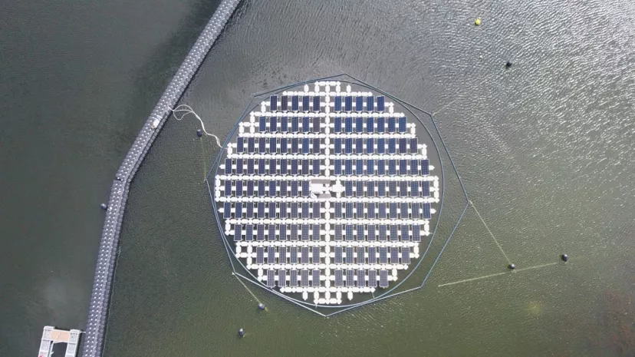

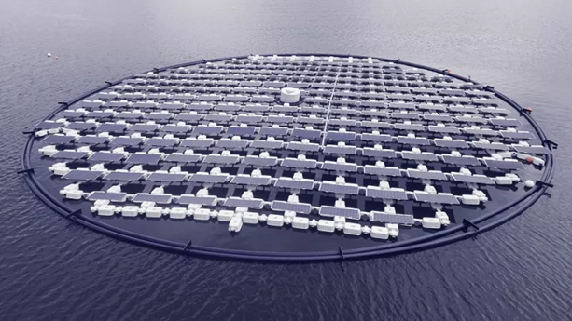

**Solaris Float**

Youtube link: <https://www.youtube.com/watch?v=8sI-bQ54loE&ab_channel=SolarisFloat>

**Technology involved:**

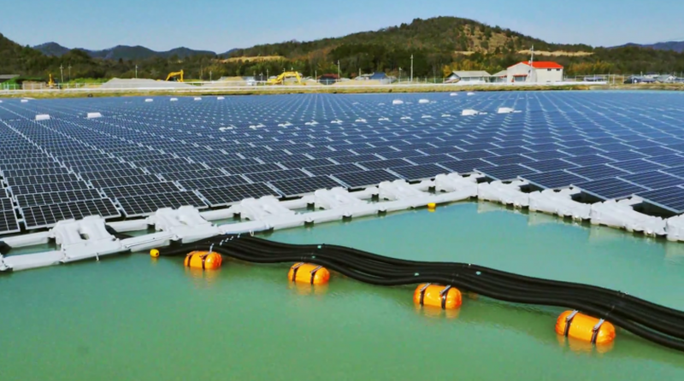

**Floating Solar Arrays:**

Research has found that solar power needs up to 50 times more space than coal and up to 100 times more space than gas to produce comparable energy levels. The land use requirement for solar may also harm biodiversity, particularly in bio-rich areas inhabited by several important species. Floating solar arrays are emerging as a useful solution to this challenge. Floating solar also solves another problem of land-based solar panels: overheating. Solar panels become less efficient when they become too hot, but floating solar panels are cooled by the water beneath them and can generate more electricity. Production is improved by as much as 15% when comparable solar panels are placed over water due to the water’s cooling effect.

Floating solar technology also improves water supply, especially in very hot locations. This is because covering water sources reduces evaporation and prevents toxic blue-green algae blooms from growing and spreading. According to one study, floating solar panels on a reservoir in Jordan reduced evaporation by 42% while generating 425 MWh of electricity each year.

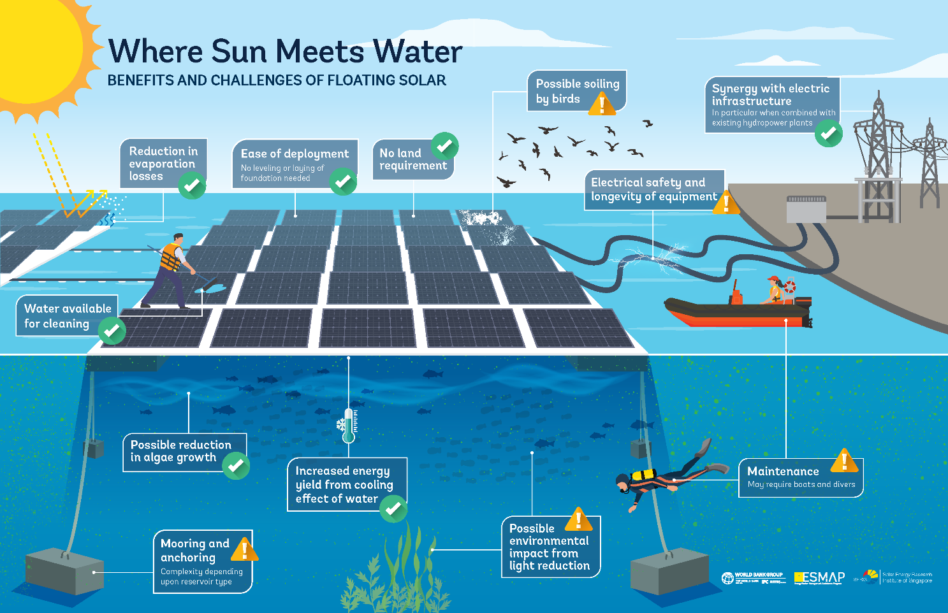

**Solar Tracking Technology:**

Solar tracking is a technology that enables solar panels to follow the sun's path throughout the day, maximizing the amount of solar energy that can be captured by the panels. By adjusting the angle of the solar panels, solar tracking systems can ensure that the panels are always perpendicular to the sun's rays, which helps to increase the efficiency of the solar energy conversion process.

There are two main types of solar tracking systems: single-axis and dual-axis. Single-axis solar trackers move the solar panels on a single axis, typically either east-west or north-south, to follow the sun's daily path. Dual-axis solar trackers, on the other hand, move the panels on both axes, allowing for even more precise tracking of the sun's position

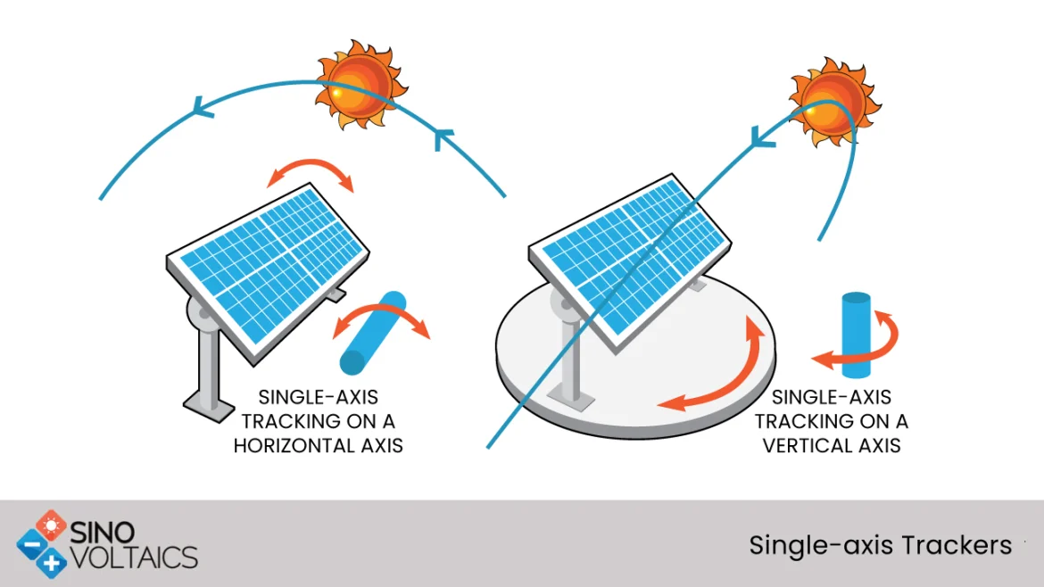One of the main advantages of solar tracking is that it can significantly increase the amount of solar energy that can be generated by a solar panel system. Studies have shown that solar tracking can increase the energy output of a solar panel system by up to 25-30% compared to fixed-tilt systems. Double-side solar panels with solar tracking could increase energy production by 35%, reducing the localized cost of electricity by 16% compared to conventional, static solar systems. The market for solar tracking technology is expected to grow at a 16% CAGR in the 2020s.

Solar tracking is most important in Earth’s northern and southern latitudes, where the sun’s incidence angle is more significant. Tracking is often unnecessary near the equator as sunlight hits the ground closer to perpendicular. Like floating solar, solar tracking increases initial and ongoing solar installation costs. However, solar tracking systems also come with some drawbacks, including increased costs and maintenance requirements. The moving parts of the solar tracking system can be subject to wear and tear, which can result in higher maintenance costs over time.

**Pre-implementation:**

Prior to theSolaris Float Protevs, there was not such a main source of energy generation in the island. But it was having a lake on the Oostvoornse Meer, in the southwest Netherlands. Which was not utilized at its full capacity and due to this reason Solaris came up with the idea to use the water body for power generation. Use of their product helped to generate electricity for the neighboring region. On sunny days, now the island can produce around 73 kilowatts of power. But thanks to its two-axis solar panels and unique sun-chasing technology, it can generate 40 per cent more energy than non-moving panels on land.

**Post-implementation:**

After the installation of Solaris Float Protevs the 25 Km radius received renewable energy and with the use of 180 floating solar panels the generation capacity reached 73 kilowatts of peak power (kWp). 378 out of the 563 households in the region got connected to the solar power plant mini-grid supply.

**Operational Management:**

To make any solar-based project sustainable, it is essential that ownership of the project should be in the hands of the community. To realize this, local people were involved in activities such as plant construction right from the beginning. After the completion of the solar plant the management and maintenance of the plant was carried out by solaris. There was no need of a special control room and associated surveillance systems but a Main room was built by the company in order to keep the record of plant and its related variables.

**Outcomes and co-benefits:**

Solaris Float Proteus has several outcomes, including economic, environmental, and social benefits.

1. Economic Benefits: Floating solar installations offered several economic benefits, such as cost savings on land and infrastructure, and higher energy yields due to the cooling effect of the water. Additionally, the Solaris Float Proteus system provided new opportunities for job creation in the solar industry.
2. Environmental Benefits: By using water bodies for solar installations, the Solaris Float Proteus system helped to reduce the impact of land use and biodiversity loss associated with traditional solar installations on land. Additionally, floating solar installations can reduced water evaporation, which is particularly relevant in regions with water scarcity.
3. Social Benefits: The installation of a Solaris Float Proteus system had social benefits, such as contributing to the development of local communities, promoting environmental awareness, and enhancing recreational activities on water bodies.
4. Energy Generation: The Solaris Float Proteus system generates significant amounts of clean and renewable energy, reducing greenhouse gas emissions and helping to mitigate the impacts of climate change.

**New Floating Systems:**

***PROTEVS +***

Unique solution with 2 axis tracking that aims to have the maximum of output capacity in comparison the installed power.

* Floating island composed of 180 PV modules, with **Two axis tracking**
* **73 kWp** of installed capacity (with 370 wp modules)
* **Vertical movement** is executed individually for **each photovoltaic module** (allowing an elevation from 0 º to 45 º angle)
* Provides an increase in energy production **up to 40%**
* Estimate of energy consumption**less than 0.5%**
* Island with 38 meter of diameter (occupied area of 1444 sqm)
* Water cooled air ensures lower panel temperatures increasing production up to 15%

***PROTEVS SINGLE360***

Specific solution with 1 axis tracking that aims to have the best balance between the occupied area and output power.

* Floating island composed of **360 PV modules,**with **one axis tracking**
* **147 kWp** of installed capacity ( with 410 wp modules)
* **PV module** presents a **fixed slope with 10º**(than can be ajusted according to the project design)
* Provides an increase in energy production **up to 30%**
* Estimate of energy consumption **less than 0.5%**
* **Water cooled air** ensures lower panel temperatures increasing production **up to 15%**
* Estimate of energy consumption **less than 0.5%**

**Limitations:**

There are a few limitations to a sun-tracking solar farm, however. For one thing, location matters—Proteus’ onboard tracking systems won’t mean much anywhere near the Equator, where the panels would stay virtually horizontal the entire day. Additionally, the setup would need to be installed in areas with comparatively weaker tidal currents and fair weather.

**Future of floating solar systems:**

The future of floating solar systems looks promising, with increasing interest and investments in this technology around the world. Here are some potential developments and trends that could shape the future of floating solar systems:

1. Increased adoption: Floating solar systems are particularly attractive in countries with high population densities, limited land availability, and significant water resources.
2. Technological advancements: There are ongoing efforts to improve the efficiency, durability, and performance of floating solar systems through technological advancements such as higher-efficiency solar panels, improved floating structures, and advanced control systems.
3. Integration with other renewable energy systems: Floating solar systems can complement other renewable energy systems such as wind and hydropower, enabling more efficient use of existing infrastructure and enhancing the stability and reliability of the energy grid.
4. Innovation in system design: There is ongoing innovation in the design of floating solar systems, including the use of new materials, shapes, and configurations that can enhance the performance and durability of the system. For example, the Solaris Float Proteus system uses modular floating structures that can be adapted to different water bodies and solar panel configurations.
5. Environmental considerations: There is increasing awareness of the potential environmental impacts of floating solar systems, such as changes in water temperature, impacts on aquatic ecosystems, and effects on water quality. Future developments in floating solar systems will need to consider these environmental impacts and incorporate measures to minimize them.

**Conclusion:**

In conclusion, Solaris Float Proteus is an innovative solar energy system that offers a promising solution for generating clean and renewable energy from water bodies. By utilizing modular floating structures and advanced solar panel technology, the system provides a reliable and efficient means of generating solar energy while minimizing the environmental impact. Additionally, the system offers a range of economic and social benefits, such as increased energy access, job creation, and improved water quality.

While there are still some challenges to be addressed, such as ensuring the long-term durability and reliability of the system, the potential benefits of Solaris Float Proteus make it an attractive option for countries and regions with significant water resources and limited land availability. As the global demand for clean energy continues to grow, floating solar systems like Solaris Float Proteus offer a promising solution for meeting this demand and promoting sustainable development.

**References:**

**Solaris Float website:**

<https://www.solarisfloat.com/the-solution-2/#top>

**Articles:**

<https://www.azocleantech.com/article.aspx?ArticleID=1632>

<https://www.euronews.com/green/2022/11/22/dutch-floating-solar-farm-tracks-suns-rays-to-absorb-more-energy-in-world-first>

<https://www.popsci.com/technology/floating-solar-panels-follow-sun/>

<https://sinovoltaics.com/technology/floating-solar-pv-systems-why-they-are-taking-off/>

**Documentary**

<https://www.youtube.com/watch?v=Y5ETDLwG_Xk&ab_channel=SolarisFloat>

**YouTube:**

<https://www.youtube.com/@solarisfloat952/videos>

<https://www.youtube.com/watch?v=RtHekjbGDhU&ab_channel=SolarisFloat>

<https://www.youtube.com/watch?v=Oj9rbhUeC3I&ab_channel=SolarisFloat>

<https://www.youtube.com/watch?v=7dQtkeLVEMA&ab_channel=SolarisFloat>

<https://www.youtube.com/watch?v=8GAkfjejysE&ab_channel=SolarisFloat>

<https://www.youtube.com/watch?v=sV9UKyES8gk&ab_channel=SolarisFloat>

**Reference For format of Case Study:**

<https://www.vasudha-foundation.org/wp-content/uploads/10)%20Reader%20Friendly%20Paper%20for%20USO_Case%20studies%20of%20successful%20decentralised%20RE%20Projects%20for%20energy%20access%20in%20India.pdf>

<http://bioenergylists.org/gasdoc/abe/IndiaBioSummary050721.pdf>

<https://www.epa.wa.gov.au/sites/default/files/Referral_Documentation/Murchison%20Hydrogen%20Renewables%20-%20Proposal%20Content%20Document_Rev2.pdf>

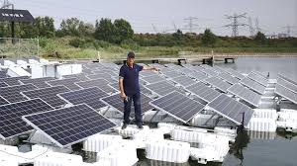**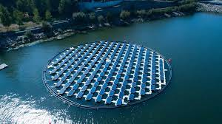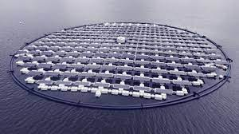Solaris Float Proteus Images:**

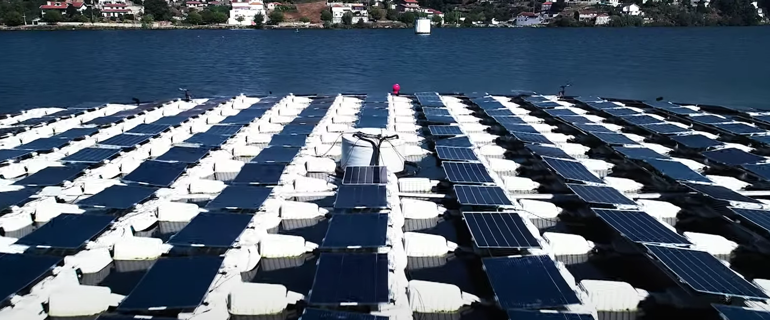

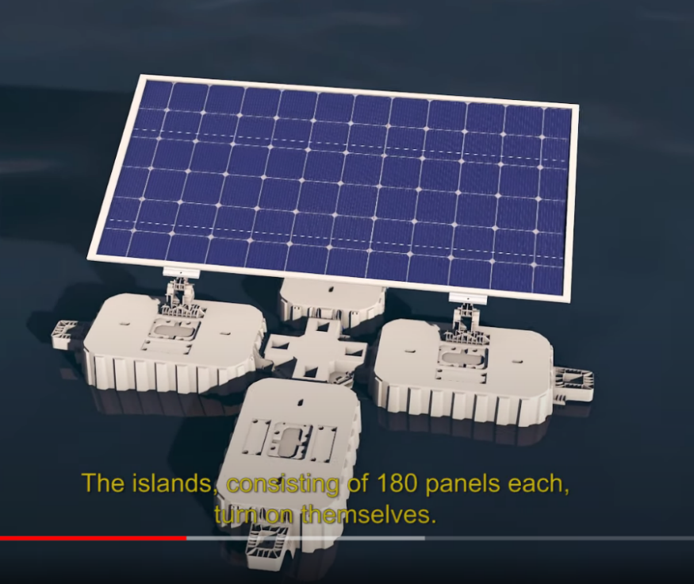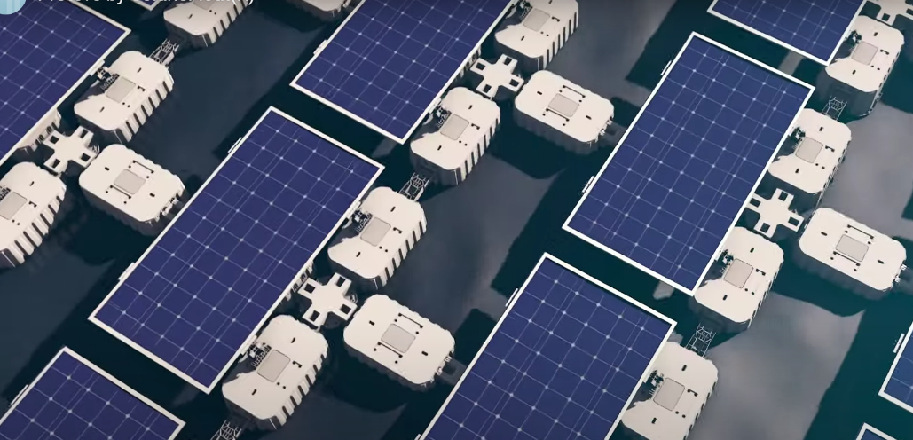

**Single module**

